**User Manual For FileShare**

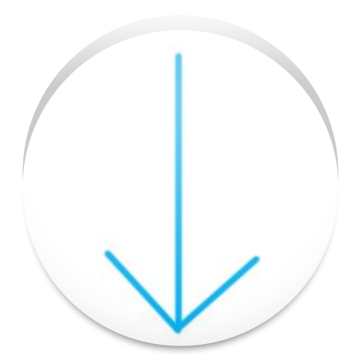

Group Members:

Zhuocheng Yu

Brian Wan

Charles Weng

Table Of Content

Table of Contents

About The Manual 3

Content 3

Intended Goal 3

Intended Audience 4

Sending Files Using FileShare 4

Material and Equipment 4

Instructions 4

Receiving Files Using FileShare 6

Material and Equipment 6

Instructions 6

Delete Files Using FileShare 7

Material and Equipment 7

Instructions 7

# About The Manual

This User manual will guide you through the process of using the FileShare android app.

## Content

This manual includes the following sections:

* Sending files
* Receiving files
* Deleting files
* Restore files

## Intended Goal

The goal of this user manual is to demonstrate the step-by-step instruction of using FileShare. The there major categories are:

## Intended Audience

This Manual is designed for people who want to understand the existing features of FileShare. Users are not expected to have experience basic android using experiences.

# Sending Files Using FileShare

This part of the manual provides instruction for sending file using the FileShare app on an android phone. You need to have FileShare installed in your before you follow these instructions.

**Note:** If you want to receive files instead of sending files, you should skip this section and move on to the next section.

## Material and Equipment

* Android phone with FileShare installed

## Instructions

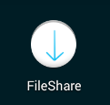

1. Located FileShare from your homescreen and click on it.

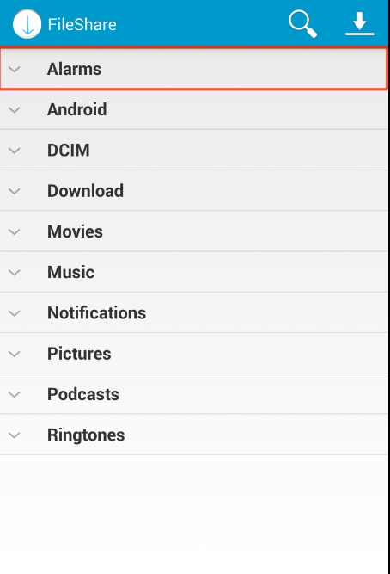

1. Select a folder tap. (e.g. Alarms)

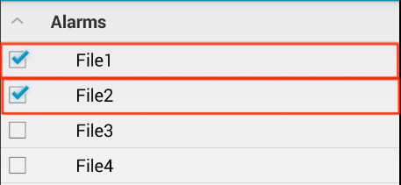

1. Select the target files. (e.g. File1, File2)

mac SSD:Users:Gooki:Dropbox:Screenshots:Screenshot 2014-06-08 21.42.01.png

1. Locate the up arrow icon from the action bar and click on it.

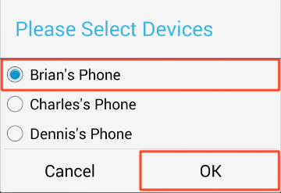

1. Select a target device and click OK.

**Note:** After you complete step 5, wait for the sending process to complete. After the sending pop up window disappears, your files are successfully sent to your selected devices.

# Receiving Files Using FileShare

This part of the manual provides instruction for receiving file using the FileShare app on an android phone. You need to have FileShare installed in your before you follow these instructions.

## Material and Equipment

* Android phone with FileShare installed

## Instructions



1. Located FileShare from your homescreen and click on it.

mac SSD:Users:Gooki:Dropbox:Screenshots:Screenshot 2014-06-08 22.05.42.png

1. Locate the down arrow icon from the action bar and click on it.

**Note:** After step 2, wait for the receiving process to complete. After the receiving pop up window disappears, you files are received.

# Delete Files Using FileShare

This part of the manual provides instruction for deleting file using the FileShare app on an android phone. You need to have FileShare installed in your before you follow these instructions.

## Material and Equipment

* Android phone with FileShare installed

## Instructions



1. Located FileShare from your homescreen and click on it.



1. Select a folder tap. (e.g. Alarms)



1. Select the target files. (e.g. File1, File2)

mac SSD:Users:Gooki:Dropbox:Screenshots:Screenshot 2014-06-08 22.19.54.png

1. Locate the trashcan icon from the action bar and click on it.

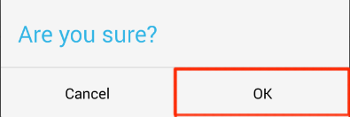

1. Click OK on the confirmation window.

**Note:** If you want to undo the deletion, follow the following steps. Else, you sucefully delete your files.

mac SSD:Users:Gooki:Dropbox:Screenshots:Screenshot 2014-06-08 22.23.50.png

1. Locate the undo button on the action bar and click on it.